3.25: Take 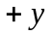 to be downward.
a) Use the vertical motion of the rock to find the initial height.

b) In 6.00 s the balloon travels downward a distance 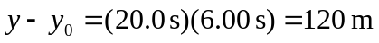. So, its height above ground when the rock hits is 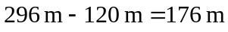.

c) The horizontal distance the rock travels in 6.00 s is 90.0 m. The vertical component of the distance between the rock and the basket is 176 m, so the rock is 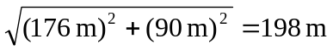 from the basket when it hits the ground.

d) (i) The basket has no horizontal velocity, so the rock has horizontal velocity 15.0 m/s relative to the basket.
Just before the rock hits the ground, its vertical component of velocity is , downward, relative to the ground. The basket is moving downward at 20.0 m/s, so relative to the basket the rock has downward component of velocity 58.8 m/s.
e) horizontal: 15.0 m/s; vertical: 78.8 m/s

